Chapter 1
INTRODUCTION

Background of the Study
Personal safety remains a growing concern in modern society, particularly for individuals who may be exposed to risky environments such as students, elderly persons, and outdoor workers. In emergency situations—such as accidents, sudden falls, or physical threats—individuals may be unable to manually seek help using conventional communication methods like mobile phones. This limitation can lead to delayed response and increased severity of incidents.

Existing emergency communication methods primarily rely on manual actions, including phone calls and text messaging. While these are widely used, they are not always reliable during critical situations where the individual is incapacitated. Furthermore, many available solutions lack automation, real-time monitoring, and immediate notification features, which are essential for effective emergency response.

The advancement of the Internet of Things (IoT) has enabled the development of intelligent systems capable of collecting, processing, and transmitting real-time data. Wearable devices integrated with sensors can monitor user activity, detect abnormal events such as falls or sudden impacts, and automatically trigger alerts without requiring user intervention. These systems can also incorporate location tracking capabilities, allowing responders to identify the exact position of the individual during emergencies.

Microcontroller-based systems play a crucial role in enabling these functionalities by serving as the central processing unit of wearable devices. When combined with motion sensors, location tracking modules, wireless communication technologies, and cloud-based platforms, these systems can support real-time monitoring and automated alert mechanisms. Additionally, mobile application frameworks enable users and designated contacts to access critical information such as location data and emergency notifications through user-friendly interfaces.

Despite these advancements, there remains a need for an affordable, accessible, and adaptable wearable safety solution that integrates automated emergency detection, real-time location tracking, and mobile-based monitoring. Many existing systems are either costly, limited in flexibility, or dependent on specific hardware configurations, making them less suitable for broader implementation.

Therefore, this study proposes the development of an IoT-based personal wearable protection device with a Mobile Application that utilizes a flexible, modular architecture. The system integrates a microcontroller unit, motion-sensing components, a location-tracking module, and a mobile application to provide automated emergency detection, real-time tracking, and instant alert notifications. This approach ensures adaptability, allowing the system to accommodate different hardware components based on availability and future improvements.

Objectives of the Study
General Objective
To design and develop an IoT-Based Personal Wearable Protection Device with a Mobile application that provides real-time monitoring and emergency alert capabilities.
Specific Objectives
- To design a wearable device integrated with motion sensors, location tracking, and manual emergency triggering.
- To establish wireless communication between the device and a cloud platform.
- To develop a mobile application for monitoring and alerts.
- To implement automated emergency notifications.
- To incorporate geofencing functionality.
- To evaluate system performance and usability.

Scope and Limitation of the Study
This study focuses on the design and development of a wearable IoT-based personal safety system integrated with a mobile application. The system utilizes a microcontroller-based device equipped with motion detection sensors, a location tracking module, and a manual emergency trigger mechanism. It is designed to collect motion and location data and transmit this information to a cloud-based platform through wireless connectivity, enabling users and designated contacts to monitor real-time location, receive emergency alerts, and manage system settings via the mobile application. The system includes features such as automated fall or impact detection, real-time location tracking, emergency alert notifications, and geofencing-based alerts. Furthermore, testing and evaluation are conducted under practical conditions to assess system performance, reliability, and usability.

However, the system operates under several limitations. It depends on wireless connectivity, which may be limited or unavailable in some areas, and location tracking accuracy may decrease in indoor or obstructed environments. The motion detection algorithm may generate false positives during sudden but non-emergency movements, and continuous operation is dependent on battery capacity, requiring regular recharging. Additionally, hardware variations during development may affect system consistency, and the mobile application may be limited to a specific platform depending on development constraints. Lastly, the system is intended as a support tool and does not replace professional emergency services.

Significance of the Study
This study is expected to provide meaningful contributions to various stakeholders by enhancing personal safety through the integration of IoT-based wearable technology and mobile application systems. The development of an automated emergency detection and alert system offers practical solutions to real-world safety challenges while also contributing to academic and technological advancement.
Individuals and Users. The proposed system enhances personal safety by providing automated monitoring, real-time location tracking, and immediate emergency alert capabilities. It reduces reliance on manual communication during critical situations, thereby increasing the chances of receiving timely assistance.
Families and Guardians. Family members and guardians benefit from the ability to remotely monitor the user’s location and safety status. This enables them to respond more quickly and make informed decisions during emergency situations, promoting peace of mind and improved supervision.
Emergency Contacts and Responders. Designated emergency contacts and responders are provided with accurate real-time location data and instant notifications during emergencies. This improves response efficiency and reduces the time required to locate and assist the individual in need.
Researchers and Developers. This study serves as a valuable reference for future researchers and developers in the field of IoT, wearable technology, and mobile application development. It demonstrates a flexible and scalable system design that can be adapted, improved, or extended in future studies.
Educational Institutions. The study contributes to the academic community by providing a practical application of theoretical concepts in IoT, embedded systems, and mobile development. It can be used as a learning resource for students and educators, supporting innovation and research in related fields.

Definition of Terms
The following terms are defined conceptually and operationally as used in this study:
Microcontroller
Conceptual: A compact integrated circuit designed to perform specific control functions in embedded systems.
Operational: In this study, the microcontroller serves as the central processing unit of the wearable device, responsible for collecting, processing, and transmitting data from sensors to the cloud-based platform.
Motion Sensor
Conceptual: A device that detects movement, acceleration, or changes in the orientation of an object.
Operational: In this study, the motion sensor is used to detect sudden movements, falls, or impacts experienced by the user and triggers an emergency alert when abnormal activity is identified.
Location Tracking Module
Conceptual: A system component that determines the geographic position of a device using satellite or network-based technologies.
Operational: In this study, the location tracking module provides real-time position data of the user, which is transmitted to the mobile application for monitoring and emergency response.
Cloud Platform
Conceptual: An online infrastructure that enables data storage, processing, and real-time synchronization across connected devices.
Operational: In this study, the cloud platform stores sensor and location data from the wearable device and facilitates real-time communication between the device and the mobile application.
Mobile Application
Conceptual: A software application designed to run on mobile devices, providing users with specific functionalities and services.
Operational: In this study, the mobile application allows users and designated contacts to monitor real-time location, receive emergency alerts, and manage system settings.
Geofencing
Conceptual: A location-based technology that defines a virtual boundary around a specific geographic area and triggers actions when the boundary is crossed.
Operational: In this study, geofencing is used to notify designated contacts when the user moves outside a predefined safe zone.
Emergency Alert System
Conceptual: A system designed to automatically notify individuals or groups during critical or dangerous situations.
Operational: In this study, the emergency alert system sends instant notifications to designated contacts when a fall is detected or when the manual emergency trigger is activated.
Manual Emergency Trigger
Conceptual: A user-activated mechanism that initiates an emergency response.
Operational: In this study, the manual emergency trigger (e.g., panic button) allows the user to send an immediate alert to designated contacts during emergency situations.
Wireless Connectivity
Conceptual: The transmission of data between devices without physical connections, typically using radio signals.
Operational: In this study, wireless connectivity enables the wearable device to transmit data to the cloud platform in real time.
Wearable Protection Device
Conceptual: A body-worn electronic device designed to monitor user conditions and enhance safety.
Operational: In this study, the wearable protection device integrates sensors, a microcontroller, and communication modules to detect emergencies, track location, and send alerts through the mobile application.

Conceptual Framework
Conceptual Framework of IoT-Based Personal Wearable Protection Device with Mobile Application.
Figure 1. The figure illustrates the Input-Process-Output-Outcome (IPOO) model of the proposed system. The input encompasses the hardware components, connectivity modules, cloud database, mobile application, and user information that serve as the foundation of the system. The process involves the integration of hardware, sensor data collection and processing, fall and impact detection analysis, location tracking, wireless data transmission to the cloud, mobile application development, geofencing implementation, and system testing and evaluation. The output includes the developed IoT-based wearable protection device, the mobile application for real-time monitoring, automated emergency alert notifications, fall detection and SOS alerts, and a geofencing alert system. The outcome reflects the expected benefits of the system, namely improved personal safety monitoring, faster emergency response, real-time tracking of the wearer's location, reliable communication between the user and emergency contacts, and enhanced personal security through wearable IoT technology.
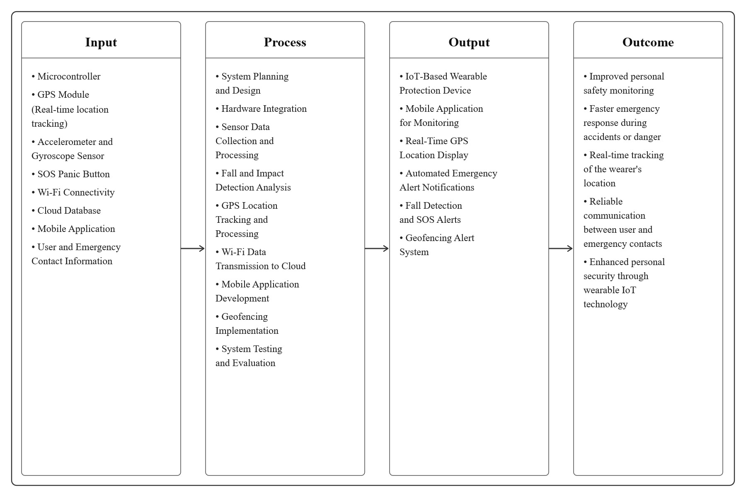
Input. The input phase encompasses all the essential components and resources required for the system to function. This includes a microcontroller that serves as the central processing unit of the wearable device, a GPS module responsible for real-time location tracking, and an accelerometer and gyroscope sensor used to detect motion, sudden impacts, and fall events. Additionally, an SOS panic button is incorporated to allow the user to manually trigger an emergency alert. Wi-Fi connectivity enables wireless data transmission, while the cloud database serves as the platform for storing and synchronizing data in real time. The mobile application acts as the primary interface for monitoring and receiving alerts, and user and emergency contact information is registered within the system to facilitate proper notification during emergency situations.
Process. The process phase describes the series of operations and development activities performed to transform the inputs into functional outputs. It begins with system planning and design, followed by hardware integration to ensure all components work cohesively. Sensor data collection and processing are carried out to gather motion and location information from the wearable device. Fall and impact detection analysis is then performed to identify abnormal movements that may indicate an emergency. GPS location tracking and processing enable continuous monitoring of the user's whereabouts, and the collected data is transmitted wirelessly to the cloud database. Concurrently, the mobile application is developed to provide a user-friendly interface for monitoring and alerts. Geofencing is implemented to define safe zones and trigger notifications when boundaries are crossed. Finally, system testing and evaluation are conducted to assess the overall performance, reliability, and usability of the system.
Output. The output phase presents the tangible results produced by the system following the completion of the development and processing activities. The primary output is the IoT-based wearable protection device, which integrates all hardware components into a functional safety solution. A mobile application is developed for real-time monitoring of the user's status and location. The system also produces a real-time GPS location display, enabling designated contacts to track the user at any given time. Automated emergency alert notifications are generated whenever a fall is detected or the SOS button is activated. Fall detection and SOS alerts serve as direct responses to identified emergency events, and a geofencing alert system notifies contacts when the user moves outside a predefined safe zone.
Outcome. The outcome phase reflects the anticipated benefits and impacts of the system upon its deployment and use. The system is expected to result in improved personal safety monitoring by providing continuous and automated surveillance of the user's condition. It aims to enable faster emergency response during accidents or dangerous situations by delivering instant alerts and location data to designated contacts. Real-time tracking of the wearer's location ensures that responders can quickly identify and reach the user in need. The system also promotes reliable communication between the user and emergency contacts through automated notifications. Ultimately, the proposed system contributes to enhanced personal security through the application of wearable IoT technology, offering a practical and accessible solution for individuals in vulnerable situations.

